**Focus keyword**: 2 person yoga poses

**Meta Title:**– 2 person yoga poses| **Vigoursoul**

**Meta Description**: 2 person yoga poses, a mind-body discipline. Asanas, breathing exercises, and relaxation or meditation are all used in various styles of yoga.

**Feature Image:**

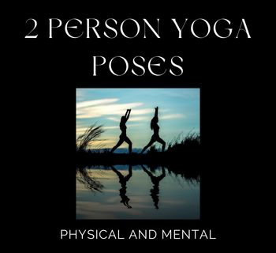

**2 person yoga poses**

Yoga was originally used as a spiritual development tool to train the body and mind to become self-aware and practice self-observation. Yoga was meant to help people develop greater levels of consciousness, self-control, and judgement.

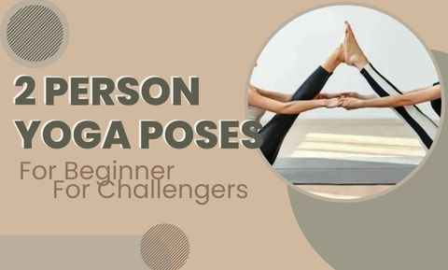

The physical parts of the yogic practice were first described by the sage Patanjali between 400 and 500 CE, despite the fact that yoga has a long history. His writings, the Yoga Sutras, are well renowned for the knowledge they include regarding asanas, or the posture-based physical aspect of yoga.

The Rigveda is when yoga-like practices are first discussed. Numerous Upanishads make reference to yoga. The Katha Upanishad, which was most likely written between the fifth and third centuries BCE, contains the earliest recorded instance of the word "yoga" with the same meaning as the current term.

Throughout the 5th and 6th century BCE, yoga continued to advance as a disciplined study and practice in the ascetic and ramaa movements of ancient India. In the second part of the first millennium CE, yoga philosophy came to be recognized as one of the six canonical philosophical schools (Daranas) of Hinduism. Beginning in tantra, hatha yoga books first appeared between the 9th and 11th centuries.

Yoga poses is a mind-body discipline. Different types of yoga use physical poses, breathing exercises, and relaxation or meditation. The ancient art of yoga may have its roots in India. It incorporates breathing exercises, meditation, and movement to enhance both mental and physical wellbeing.**2 person yoga poses** becomes popular in present century.

**Beginner Acro Yoga for 2 Persons**

You will have a base in acro yoga who will sustain the weight of your partner. On the other hand, the flyer is the individual who is often raised off the ground by the base. A spotter who can support the flyer and base as necessary should be present as well. If you're just starting off with the practice, **2 person yoga poses** for two partners is a very wise choice.

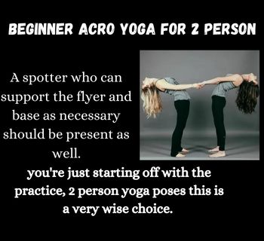

The best beginner options for **2 person yoga poses** introducing yourself and your partner to the practice and getting acquainted with the particular difficulties that come with it are these poses, if you're interested in trying acro yoga.

**Top 10 Acro Yoga Poses**

**Plank on Plank**

An excellent first pose in acro yoga is plank on plank. It strengthens your core and arms and gets you used to exercising with a partner. In one still posture, the plank effectively exercises every muscle in the body. You may strengthen your abs, hands, wrists, arms, shoulders, back, core, glutes, and legs by holding this pose for 30 seconds several times per day.

**Plank Press**

Another excellent beginner position is the plank press, which builds confidence between the partners and enables the base to become accustomed to bearing another person's weight. It serves as a foundation for Front Plank. Plank is essentially a traditional yoga motion that is also included in Pilates mat practice.

**Folded Leaf**

## In order to build confidence and comfort with the sensation, Folded Leaf will give the flyer the chance to actually lift off the ground. Folded Leaf Yoga unites the mind, body, spirit, energy, and emotions. Connecting you ultimately to your inner self and greater power.

## Front Plank

## Plank Press is advanced by Front Plank, allowing the flyer to fully lift off the ground. Pilates plank might emphasis holding the abs in more, and yoga plank might hold the plank for a longer period of time.

## Partner Forward Folds

## A fun way for both partners to get a powerful back and hamstring stretch is by doing partner forward folds. In the forward fold, your upper body is virtually folded over your legs to stretch. Uttanasana, which means "forward fold" in Sanskrit, is a common yoga stance (or asana) that is a part of the sun salutation, a popular sequence of poses.

## Fish on a Rock

## Acro Yoga's Fish on a Rock pose is more restorative. Both the flyer and the base can benefit greatly from having their hips and backs opened up. Numerous fish species are referred to as "rockfish" because of their propensity to conceal themselves amid boulders. Numerous species of fish used as food go by the name rockfish.

## Down Dog L-Shape

## As they are in Downward Facing Dog, the flyer may offer the base a beautiful extending through the spine in the Down Dog L-Shape Pose. The flyer uses the inversion to build arm strength and practice their handstand.

## Foot to Hand Pose

## The foot to hand stance is a fantastic way to experiment with balance and create the impression that you are bearing another person's weight. It takes a level of balance and breath control that can only be attained when the practitioner is totally engaged and acutely aware. This extremely beneficial pose is based in the feet and legs.

## Chair Pose on Shins

## While the flyer improves their balance, the base can strengthen their legs in Chair Pose on Shins. An advanced level yoga pose that is done standing up is called Chair Pose Shins Partner. Stretch, strength, and balance are additional requirements for the Chair Pose Shins Partner.

## Jedi Plank

## If both people want to engage their cores and get a good exercise, the Jedi Plank is a fantastic stance to practice. The Jedi Plank is a balancing and strengthening posture that gets the arms and core ready for more difficult arm-balancing poses. Start in tabletop posture or hands and knees on the mat.

## Couple Yoga Challenge Pose

## 2 person yoga poses (3).jpg

## Partner Forward Fold

## As you sit across from your partner, spread your legs apart and straighten them in front of you. Put your partners' feet opposite each other and grab each other's forearms. Then, while the other gently pulls you toward them, one of you softly swings forward from the hips. Once more, when they feel a stretch in their hamstrings, they should hold this position for a few breaths.

### ****Seated Cat Cow****

This is a variant of the traditional "cat-and-cow" motion. **2 person yoga poses** give access to cross your legs in front of your partner and grab tightly onto each other's forearms. Next, exert equal resistance on both of your shoulders, and draw them back and down. After a brief period of holding this position, slowly switch a few times between the cat and cow positions.

### Twin Trees

With your feet about hip width apart, **2 person yoga poses** gives stand shoulder to shoulder with a companion. Both spread your toes and press your inside leg firmly into the ground while supporting your entire foot with weight. After that, carefully raise the second leg, bending the knee, and placing the sole of your foot against the side of your lower leg or, if you feel stable enough, the inner of your thigh.

### Chair Pose

With your feet hip width apart, **2 person yoga poses** allows first one to stand back to back with your partner. Slowly walk out your feet a bit and lean onto their back for support. If it feels natural to you, you can interlace your arms to add support. To make sure you are on time with one another for the next step, you will need to communicate. You can do this several times or, alternatively, for a light-hearted challenge.

### Double Downward Dog

First partner of **2 person yoga poses** assumes the downward dog position. Partner 2 then assumes the same position as Partner 1, puts their hands in front of Partner 1, slowly lifts their legs, and rests their feet against Partner 1's lower back.

You can start in the down dog position a short distance in front of your partner, step your feet onto the lower back of your partner, and then walk your hands in while straightening your legs to create the down dog shape. You can also step your feet onto your partner's lower back from the side.

**Buddy Boat**

Place yourself across from your partner among **2 person yoga poses**, about a leg's breadth apart. Grab your partner's hands by reaching outside of your legs. Begin to bring the soles of your feet together while bending your knees.

Instead of sitting on your pelvis, try to find equilibrium with your partner on both of your sit bones. By tilting your pelvis into a neutral position and sitting up straight, you can make sure you are on your sit bones.

### Chair & Shoulder Stand

Partner 1 begins in the seated position (they may need to rest their back against a wall to keep balance to begin with). The second partner of **2 person yoga poses** pushes first one into a shoulder stand while placing their feet on the thighs of the first partner. A few breaths later, release the pose after holding it.

### Wheel

This one calls for some gymnastics! One person among **2 person yoga poses** begins by assuming the cobra position while lying on their stomach. There are two ways for the second partner to begin the posture. They can either lay on their back, with the base partner reaching up and grabbing their ankles one at a time.

### Flying Bow

The flying superman position allows for the execution of this pose. Once in the flying superman pose, the base firmly grasps the top person's shoulders to support them as they bend one leg and reach for their ankle, then do the same on the other side while bending their backs deeply to create the bow pose.

**2 Person Yoga Poses-FAQS**

**What is yoga's primary goal?**

The goal of yoga, according to Natalie Nevins, DO, a board-certified osteopathic family physician and certified Kundalini Yoga instructor in Hollywood, California, is to increase strength, awareness, and harmony in the body as well as the mind.

**What guidelines govern yoga?**

5 Guidelines for Beginning Yoga

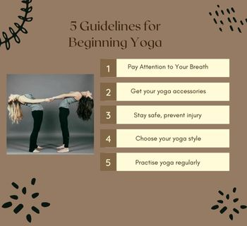

* Rule #1 of yoga: Pay Attention to Your Breath
* Rule #2 of yoga: bring a yoga mat.
* Rule #3 of yoga: Dress comfortably
* Rule #4 of yoga: Attend Class
* Rule #5 of Yoga: Accept Bare Feet

**What are the seven yoga stages?**

Asana (yoga postures), pranayama (breath control), pratyahara (withdrawal of the senses), dharana (concentration), dhyana (meditation), and samadhi are the eight limbs of yoga (absorption).

**Who is the yoga's founder?**

Tirumalai Krishnamacharya was an Indian yoga instructor, ayurvedic healer, and scholar who lived from 18 November 1888 to 28 February 1989.

**How many different kinds of yoga exist?**

Ashtanga yoga, Hatha yoga, Hot yoga, Iyengar yoga, Kundalini yoga, Power yoga, Restorative yoga, and Vinyasa yoga are eight well-liked types of yoga.

**Conclusion**

In conclusion, yoga has attracted many people to adopt it in order to help them lead healthy lifestyles because of the health benefits it offers. It is noteworthy that the exercise combines physical postures, breathing practices, and relaxation techniques to balance a person's mind and body.**2 person yoga poses** gives different ways to perform yoga for partners,